Ex.No. 12: NB-IoT vs LTE-M Throughput Simulation Date
Objective 1:
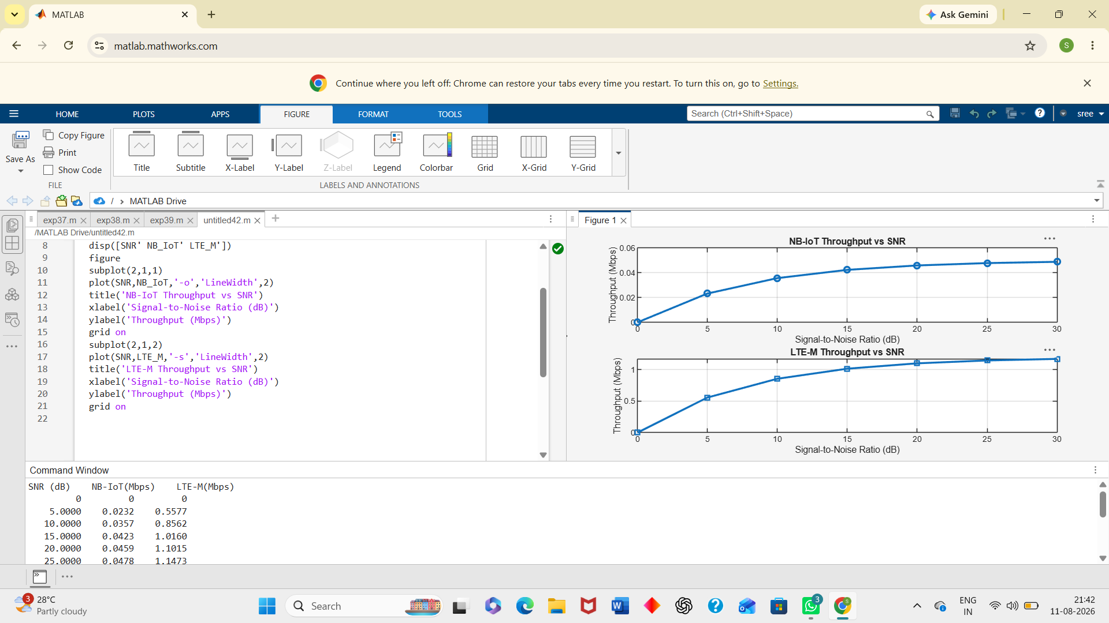
Objective 2:
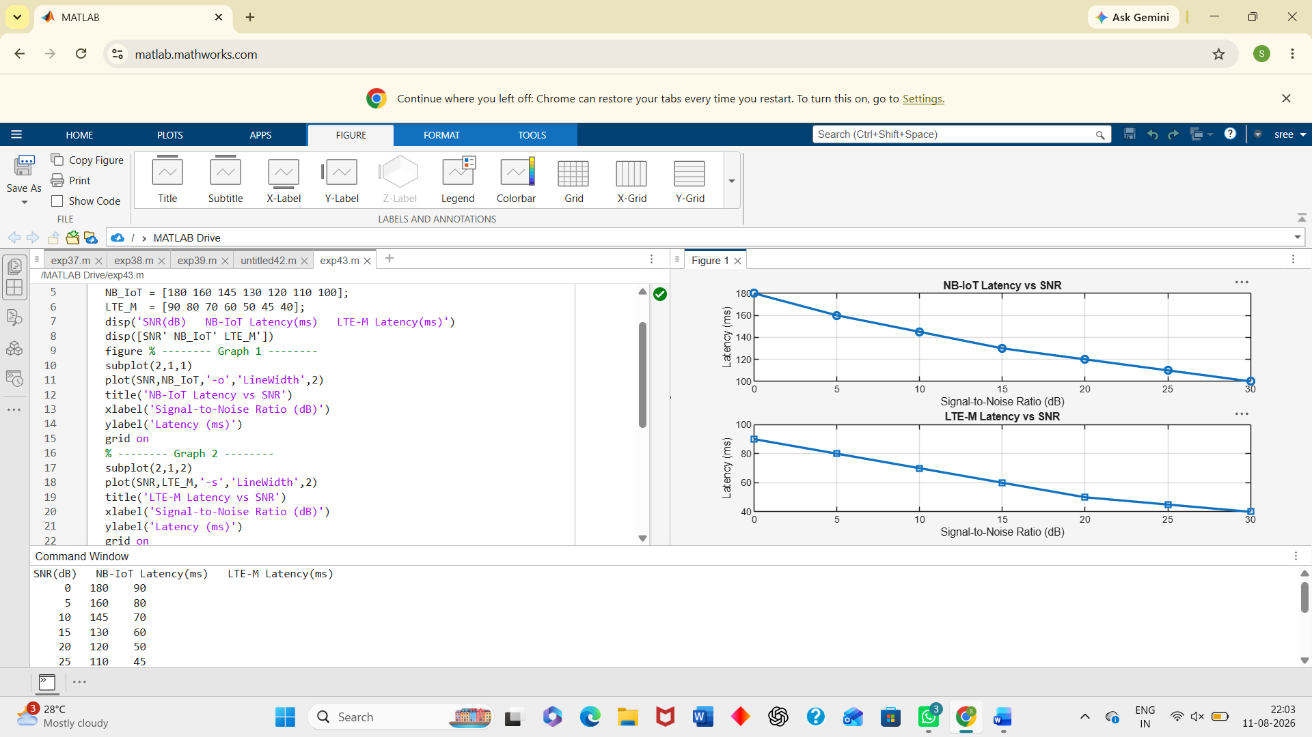
Objective 3:
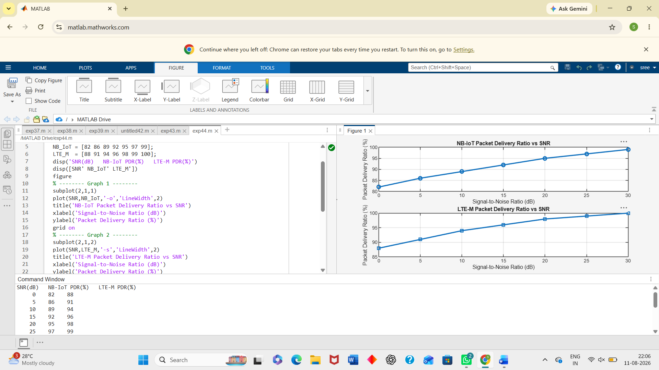
Result:
1. The throughput performance of both NB-IoT and LTE-M was successfully simulated, and LTE-M achieved higher throughput than NB-IoT under the same network conditions. 2. The latency analysis showed that LTE-M provides lower communication delay compared to NB-IoT, making it more suitable for real-time IoT applications. 3. The Packet Delivery Ratio (PDR) of both technologies improved with increasing SNR, with LTE-M demonstrating slightly higher reliability than NB-IoT during data transmission.

